16 March 2007 The Weekly Bulletin of Rotary Club of Kathmandu Mid-Town Bc # 37 of 2006-07
Rotary Club of Kathmandu Mid-Town
Breakfast Chatter




District : 3290 Web: www.rotarymidtown.org.np Club Id : 26776

MARCH IS WORLD ROTARACT (WEEK) MONTH
On the occasion of Rotaract Week
Fellow Rotarians are encouraged to post the following message to their own or other youngsters:
ARE you a young professonal who wants to make your community a better place?
WOULD you welcome the chance to expand your circle of friends at home and around the world?
ARE you looking for ways to hone your leadership skills and explore career opportunities?
THEN Rotaract is for you !

Guest Speaker Dr Susanne von der Heide provided interesting slides-show with slides depicting
Kathmandu Valley then and now at the Club meeting on 9 March 2007.
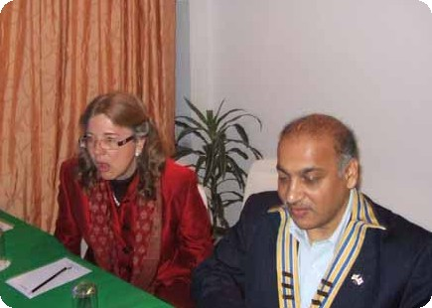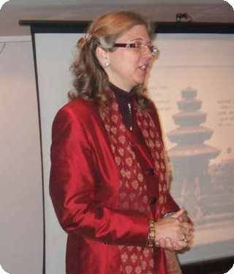
a) Guest Speaker Dr Susanne answering questions put forward by Club members
while President CK Golchha looks on; b) Dr Heide discussing on slides at slideshow.

Weekly Meetings and Programs :
Date | Program/Speaker | Program/Topics of Presentation
16 March 2007 | Joseph/Brigitte Cazalis-Collins | One couple's experiences and reflections while working on projects in Nepal.
23 March 2007 | Rtr Prashanna Shrestha, | Joint meeting with Rotaract Club of KMT
30 March 2007 | Dinner meeting | Dinner meeting
6 April 2007 | Dr Lynn Bennett | ?

Friday, 16 March :
Joseph/Brigitte Cazalis-Collins will be jointly talking at the Club meeting about their experiences and reflections while working on projects in Nepal. Mr Joseph H Collins had worked as an economic advisor to government ministries and Nepal Rastra Bank for several years. He was involved in project preparation concerning International finance center in Nepal.
Ms Brigitte Cazalis Collins is the Executive Director of Friends of Maiti Nepal in the United States. She was a member of the Founding Board of the Tibetan Resettlement Project, which provided sponsors, housing and employment to Tibetan family who immigrated to the US under the Immigration Act.

Trees to produce fuel !
It's like having a petrol station in your backyard. What's more, it's eco-friendly, comes from a tree and can actually run your vehicle ! It's bio-diesel. And Gujarat government has taken a lead in its development with a number of pilot projects under way.
Ahmedabad district authorities have embarked on a multi-purpose project to cultivate ratanjot, the seeds of which produce bio-diesel. Extraction from the seed can be used also for making pesticides and herbal medicines. The non-edible oil extracted from ratanjot has chemical properties similar to those of diesel and thus it could be used in place of kerosene, charcoal, coal and furnace oil. It is already being used in small quantities as fuel vehicles. 2.85 million ratanjot trees will produce 785,000 kgs of seeds. About 200,000 litre bio-diesel can be extracted from the seeds. Bio-diesel can be produced from plants like karanj and mahuda apart from ratanjot.
The state forest department has developed the project for commercial exploitation of the plant as an alternative non-polluting and renewable source of fuel.
Ratanjot extract can also be used in making varnish, soaps, candle-sticks, cosmetics and pesticides. The oil is also considered effective in treating cancer, rheumatism, dropsy and diarrhoea.
Source: The Himalayan Times

On Lighter Side : Click at the figure ⇩

The Four-Way Test is one of the hallmarks of Rotary. Since it was developed in 1932, it has never ceased to be relevant. Its four brief questions are not based on culture or religion; instead, they are a simple checklist for ethical behavior. They transcend national borders and generations.
RI President William B. Boyd

16 March 2007 The Weekly Bulletin of Rotary Club of Kathmandu Mid-Town Bc # 37 of 2006-07

Editor: RR Shrestha, Club Service Director email: rryes@wlink.com.np

